Creating Greeting Cards On Your PC
There are occasions when a single card is needed, in this guide, it will be a Thank You card. To achieve a professional look purchasing a package of printable cards with envelopes included is recommended. One supplier is Avery and their products are sold at Staples and other PC supply stores. This is an activity that can include family members participation.
A picture from a digital source and some words create a card. Perhaps taking a picture of the event, place or item received can be the theme of the card. Use a digital camera, phone or tablet or ask any grandchild to assist as photographer. Enter “clip art” into Google or Bing to find websites with thousands of artwork clips.
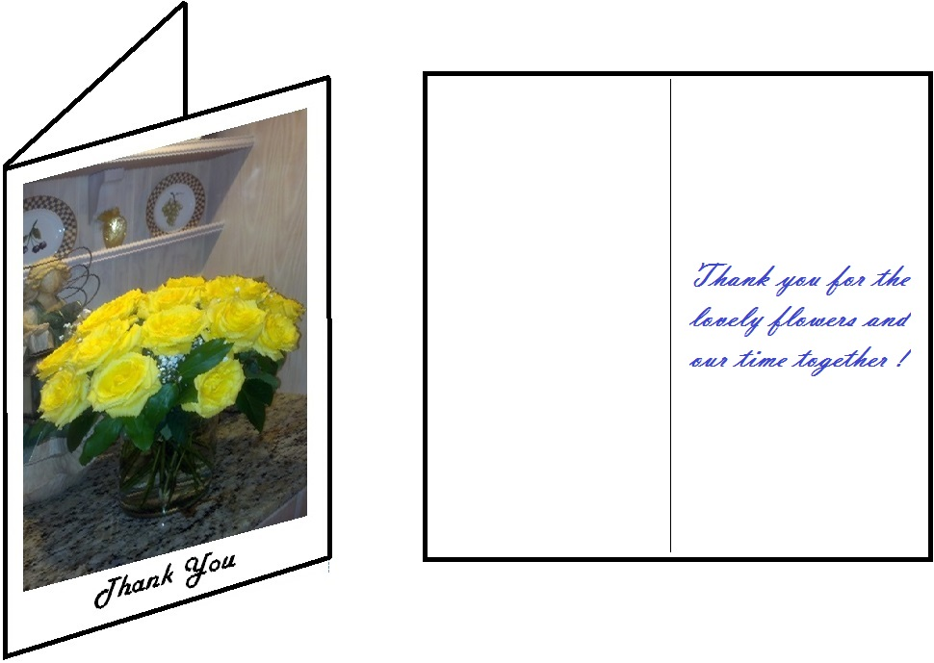
What do you need ?
- A PC with a printer that can produce picture quality prints
- Access to the internet to visit www.Avery.com
- MS Word (see appendix A) OR a program designed to create a card (see appendix C)
- A package of Avery greeting card stock or note card stock
Avery makes several sizes and fold types. Therefore, it is best to purchase the card stock before proceeding with the rest of the instructions. The templates for MS Word retrieved from the Avery website are specified by a code number (i.e. 3265) found on the card stock package.
There are other applications like business cards and mailing labels (i.e. 5161) which can be created by applying the techniques covered in this document. The Avery website has additional products which may be of interest.
Appendix A.
Using MS Word:
What do we do?
- Fetch a template from the Avery website www.avery.com
- Create a Word document by opening the template
- Insert words and picture(s) as desired
- Print the result on plain paper as a draft (trial run)
- Print the finished card using the card stock.
The template will define the format of the card showing the panels and setting the margins. For this type of card stock, if there are words/pictures in more than one panel the printer needs to pause and you need to turn the card according to instructions provided then resume printing.
Fetch a template
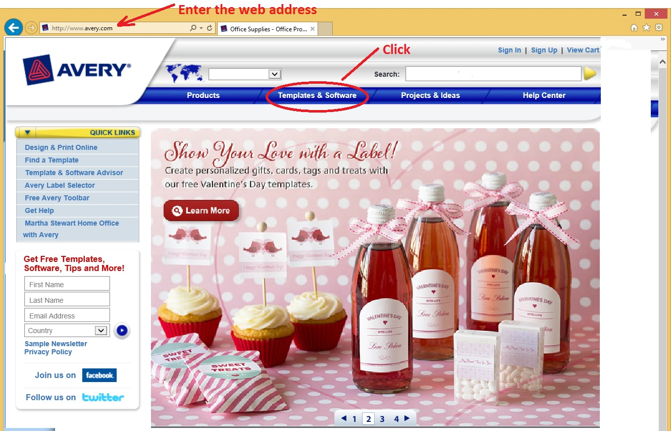

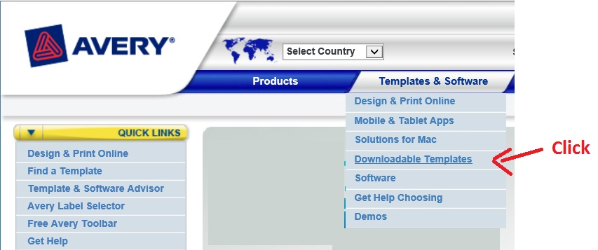
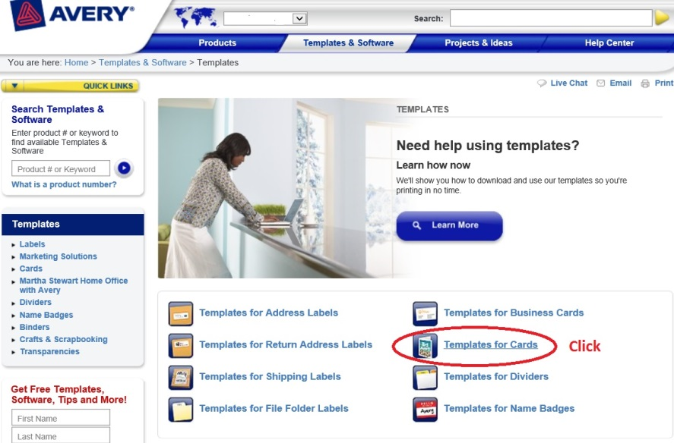

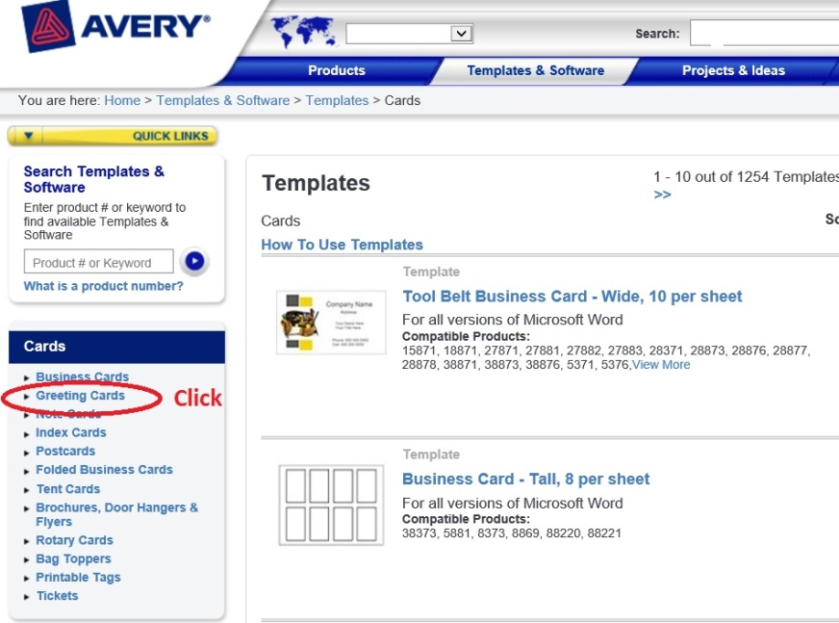
x
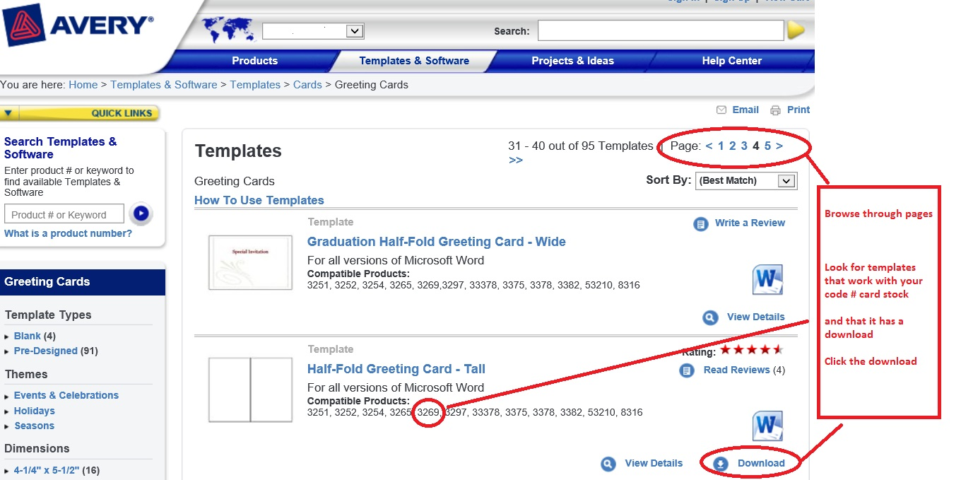

If not already registered with Avery, there will be a window prompt to get your name and email address. There is no charge but this makes Avery’s marketing staff happy.
Your PC may have different window appearance then mine. Therefore some of the instruction is functional rather than illustrative.. If your security protection program flashes or prompts, you’ll need to give permission to proceed.
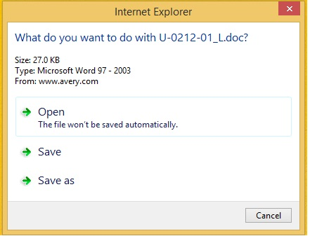
The best choice is SAVE AS, then OPEN and lastly SAVE (might be hard to find this file later)

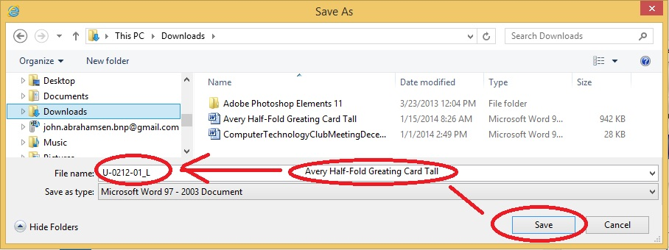
Windows displays it’s file explorer window. Pick the folder to put this templates into. In this illustration a “Downloads” folder. Later, in Word, open this same folder and select this template.
Before clicking the SAVE button consider changing the template name assigned by Avery to something more descriptive. If this name already exists, then SAVE requires confirmation (yes).
Create a Word document
Open MS Word
Click FILE then Open
In the file explorer window find and click on the folder in the tree on the left side of the window. Then find the newly downloaded template file and double click it. Or click it and then click the OPEN button.
Alternatively, on some PCs just find the template file in file explorer and double click it. This should launch Word and open the template automatically.
If all is well then the template will be displayed as a new Word document.

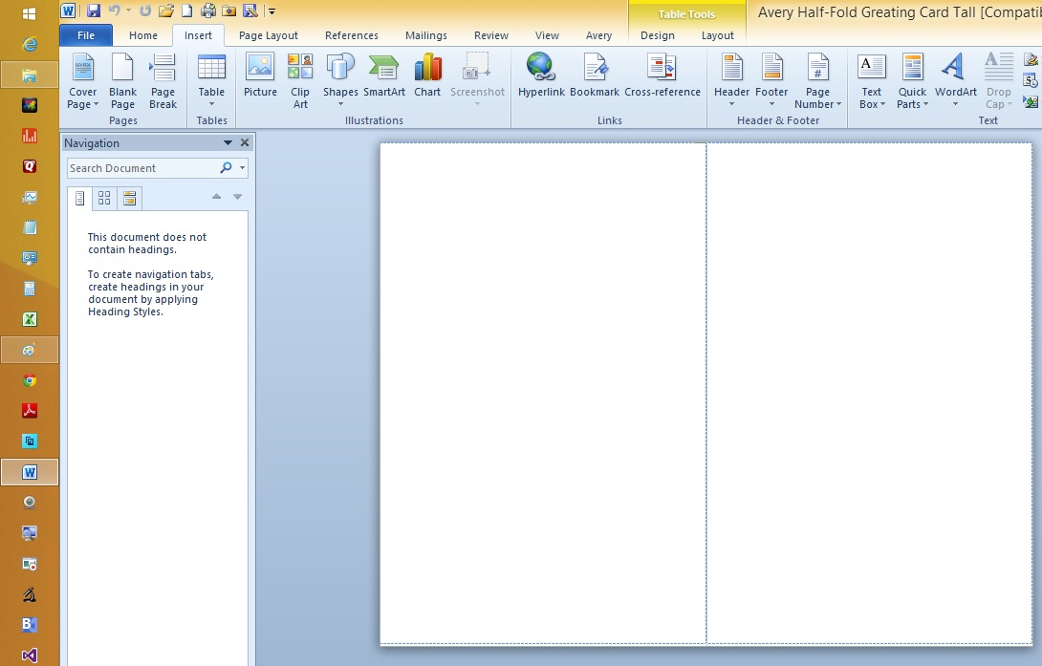
Insert words and picture(s)
The card fold line breaks the page into 4 panels. Click on the panel in the document where the picture is to be imported then click the Word menu INSERT then PICTURE. Word will display the file explorer. Find and double click the picture. Or a single click will identify the picture and then click the insert button.
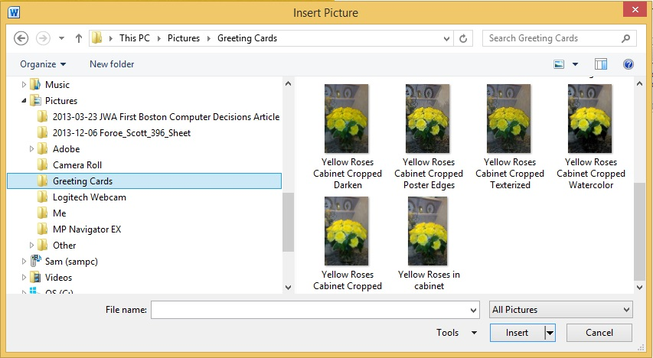

There are other pictures there – like watercolor. In Appendix B this will be explained.
The result is:
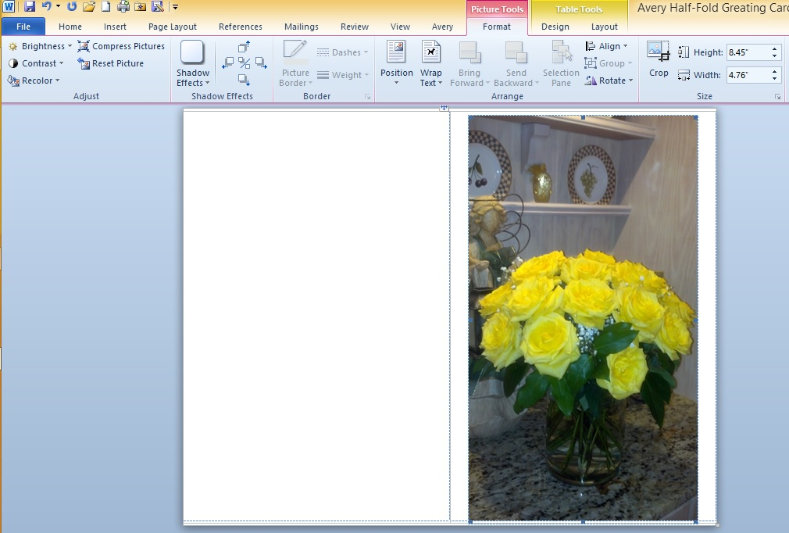
Now click on the picture. This should make the picture sizable. Using the mouse click and drag the size marker to adjust the size to permit text to be added. Or put text in another panel.
Click on the page below the resized picture to set the cursor and then type in Thank You.
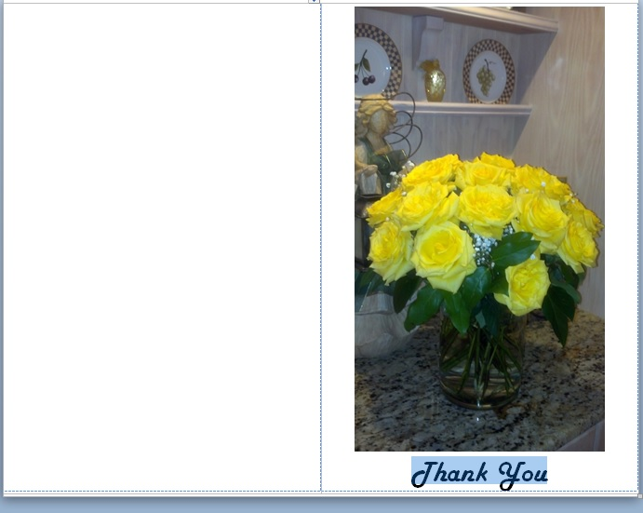
Highlight the text. Use the text tools to change the font, size and color .

Print the result on plain paper
You’re ready to print. Don’t forget to FILE then SAVE AS this document.
Put some plain paper in and click the Word print button or menu item PRINT as a trial before using the expensive card stock.
Make several copies. Change the picture and/or text. Then FILE then SAVE AS for each variation by adding a version number to the name before clicking SAVE AS.
If the photographer (grandchild) has made several pictures, then pick some and show the result as part of the consultation stage.
Perhaps after following the suggestion in Appendix C and/or have tried other wording, your significant other may want the final Word. No pun intended.

Print the finished card

Appendix B.
Some photo editor applications can apply special effects to a photograph. This may add interest to the picture or may enhance the appearance.
Using the Adobe Photoshop program, let’s open the flower photo.
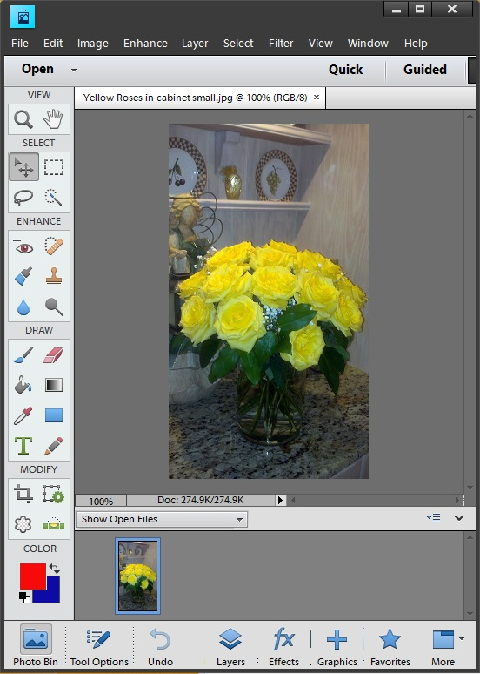
Click the FILTER menu item then ARTISTIC then WATERCOLOR. Other apps may call this special effects.
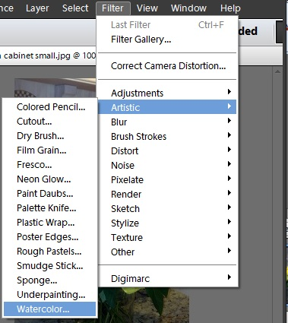
Produces this. Use SAVE AS , append watercolor to the name.
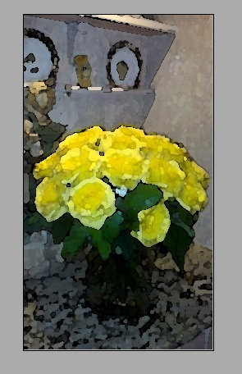
Photoshop can be used to crop, lighten, darken, recolor and much more.
Appendix C.
The Avery package(on the back) lists other alternative ways to create and print the cards if you do not have MS Word.
There are programs like Adobe Photoshop which can be used with templates found in the same place as the Word templates.
Applications such as American Greetings “CreataCard” prompt you for all the elements, such as words and pictures. Then guide through the printing part. Templates are not used. The program will react to the card stock code number. These apps are highly specialized for card creation only. They are a less expense choice than Word or Adobe. More family friendly to use.
Look to the Avery package or the website for comprehensive information.
The concepts presented herein can be applied to creating personalized:
- Greeting Cards
- Note Cards
- Postcards
- Photographs annotated or embellished
- Magnet sheets
- Labels
- T-shirts (using transfers)
- Banners
- Removable stickers
- Decals
- Textured Canvas
- Calendar Kit

